Aerospace Industry Tool for Calculating Scope 3 Greenhouse Gas Emissions of Purchased Goods & Services and Capital Goods: User Guide
20 August 2021
Version 1.0

This document is released for purpose of supporting voluntary accounting and reporting of greenhouse gas (GHG) emissions associated with purchased goods and services and capital goods across the aerospace industry.
Any further distribution or use requires the written consent of IAEG in accordance with our copyright statement below.
© 2021 IAEG®
The International Aerospace Environmental Group® ("IAEG®") is the owner of this material. This material may not be used for any purpose other than that for which it is provided without the express written consent of IAEG®. IAEG® will accept no liability for any damages from any use of this material including without limitation any direct, indirect, incidental, special and consequential damages, loss of data, income, profit or goodwill, loss of or damage to property or claims of third parties. IAEG® reserves the right to add to, change or delete its content or any part thereof without notice.

Version History
Date | v# | Modified By | Section, Page(s) and Text Revised
20/08/21 | 1.0 | IAEG WG3 | Initial Release

Table of Contents
Version History 2
1 Glossary 4
2 Introduction 5
2.1 Context 5
2.2 Definitions 5
2.2.1 Purchased goods and services 5
2.2.2 Capital goods 6
3 Methodology overview 7
3.1 Available approaches 7
3.2 Main features of the methodology 8
3.3 Purchased Goods & Services categories for the purpose of GHG accounting 8
3.4 Capital Goods categories for the purpose of GHG accounting 9
4 Step-by-step guide 10
4.1 Getting familiar with the tool – “Read me” sheet 10
4.2 Identifying the relevant assessment approach – “Decision tree” sheet - 10
4.3 Data collection 11
4.3.1 Identifying data source 11
4.3.2 Ensuring materiality in data collection 11
4.3.3 Data tracking 12
4.4 Filling with the inputs – “Import data” sheet 12
4.4.1 Mapping categories 12
4.4.2 Category and subcategory examples 15
4.5 Back-end calculations – “GHG emissions calculation” sheet 16
4.6 Reviewing the results – “Results overview” sheet 16
4.6.1 Associated emissions and share of total emissions 16
4.6.2 Distribution of GHG emissions by degree of decreasing significance 18
5 Conclusion 20

DISCLAIMER
THIS DOCUMENT IS NOT A STANDARD. IT IS NOT INTENDED TO, NOR SHOULD IT BE USED TO SUPPORT A CAUSE OF ACTION, CREATE A PRESUMPTION OF A BREACH OF LEGAL DUTY, OR FORM A BASIS FOR CIVIL LIABILITY. NOTHING EXPRESSED OR IMPLIED IN THIS INFORMATIONAL DOCUMENT IS INTENDED, OR SHALL BE CONSTRUED, TO CONFER UPON OR GIVE ANY PERSON OR ENTITY ANY RIGHTS OR REMEDIES UNDER OR BY REASON OF THIS INFORMATIONAL DOCUMENT.
THIS DOCUMENT IS PROVIDED BY THE INTERNATIONAL AEROSPACE ENVIRONMENTAL GROUP (IAEG) FOR INFORMATIONAL PURPOSES ONLY. DETERMINATION OF WHETHER AND/OR HOW TO USE ALL OR ANY PORTION OF THIS DOCUMENT IS TO BE MADE IN YOUR SOLE AND ABSOLUTE DISCRETION. RELIANCE SHOULD NOT IN ANY WAY BE PLACED ON THIS DOCUMENT FOR ISO CERTIFICATION OR OTHERWISE. NO PART OF THIS DOCUMENT CONSTITUTES LEGAL ADVICE. USE OF THIS DOCUMENT IS VOLUNTARY.
IAEG DOES NOT MAKE ANY REPRESENTATIONS OR WARRANTIES WITH RESPECT TO THIS DOCUMENT OR ITS CONTENTS. IAEG HEREBY DISCLAIMS ALL WARRANTIES OF ANY NATURE, EXPRESS, IMPLIED OR OTHERWISE, OR ARISING FROM TRADE OR CUSTOM, INCLUDING, WITHOUT LIMITATION, ANY IMPLIED WARRANTIES OF MERCHANTABILITY, NONINFRINGEMENT, QUALITY, TITLE, FITNESS FOR A PARTICULAR PURPOSE, COMPLETENESS OR ACCURACY. TO THE FULLEST EXTENT PERMITTED BY APPLICABLE LAWS, IAEG SHALL NOT BE LIABLE FOR ANY LOSSES, EXPENSES OR DAMAGES OF ANY NATURE, INCLUDING, WITHOUT LIMITATION, SPECIAL, INCIDENTAL, PUNITIVE, DIRECT, INDIRECT OR CONSEQUENTIAL DAMAGES OR LOST INCOME OR PROFITS, RESULTING FROM OR ARISING OUT OF A COMPANY’S OR INDIVIDUAL’S USE OF THIS DOCUMENT, WHETHER ARISING IN TORT, CONTRACT, STATUTE, OR OTHERWISE, EVEN IF ADVISED OF THE POSSIBILITY OF SUCH DAMAGES.

Glossary

Acronym | Definition
BoM | Bill of Materials
CG | Capital Goods
EF | Emission Factor
GHG | Greenhouse Gases
IAEG | International Aviation Environmental Group
ISO/TR | International Organization for Standardization/Technical Report
PG | Purchased Goods
PG&S | Purchased Goods & Services
PP&E | Plant, Property, & Equipment
WG3 | IAEG Work Group 3

Introduction

Context
As described in “GHG Reporting Guidance for the Aerospace Industry, A Supplement to the GHG Protocol Corporate (Scope 1 and 2) and Value Chain (Scope 3) Accounting and Reporting Standards”, the International Aerospace Environmental Group (IAEG) identified both “Purchase of Goods and Services” (PG&S) and “Capital Goods”(CG) categories as potentially relevant Scope 3 categories for member companies and their value chain partners. IAEG consequently decided to develop relevant methodology and guidance materials to allow aerospace and defense companies to report greenhouse gas (GHG) emissions for these categories.
This document provides guidance for assessing GHG emissions inventories associated with PG&S and CG. An overview of the methodology is presented, followed by step-by-step instructions on how to apply the methodology in conjunction with a simplified calculation tool (the “tool”) specifically developed for aerospace-related PG&S and CG GHG emissions accounting.

Definitions

Purchased goods and services
The GHG Protocol Corporate Value Chain Accounting Reporting Standard, defines PG&S as “this category includes emissions from all purchased goods and services not otherwise included in the other categories of upstream scope 3 emissions (i.e., category 2 through category 8)”.
Examples of PG&S:
- Titanium Casting
- PVC pipe
- Nylon
- Advertising
- Telecom service
Purchased goods are typically items that are directly related to making the final product (such as intermediate goods) or non-product-related inputs (such as office supplies or manufacturing spare parts).
Services are defined as intangible products used in the conception of the final product or service offered by the company.
Companies should follow their own financial accounting procedures to determine whether to account for a purchased product as a capital good or as a purchased good or service. Companies should not double count emissions between both categories.
Note: Accounting conflicts might arise between the default choices allocated to the different types of products in this methodology and the company’s procedures. In such situations (i.e., a given machinery or vehicle considered as a PG rather than a CG), the user should inform IAEG Work Group 3 (WG3) of the mismatch to help with methodological/tool improvement and, in the meantime, reporters should carefully select what seems to be the most appropriate category for the specific good, and document any assumptions associated with the allocation.

Capital goods
The GHG Protocol Corporate Value Chain Accounting Reporting Standard, defines CGs as “final products that have an extended life and are used by the company to manufacture a product, provide a service, or sell, store, and deliver merchandise. In financial accounting, capital goods are treated as fixed assets, for instance as plant, property, and equipment (PP&E).”
Examples of CG:
- Equipment
- Machinery
- Buildings
- Facilities
- Vehicles
As mentioned in the PG&S subsection, companies should follow their own financial accounting procedures to determine whether to account for a purchased product as a capital good or as a purchased good or service. Companies should not double count emissions between both categories.
Accounting conflicts might arise between the default choices allocated to the different types of products in the methodology and the company’s procedures. In such situations (i.e., a given machinery or vehicle considered as a PG rather than a CG), the user should inform IAEG Work Group 3 (WG3) of the mismatch to help with methodological/tool improvement and, in the meantime, reporters should carefully select what seems to be the most appropriate category for the specific good, and document any assumptions associated with the allocation.

Methodology overview

Available approaches
Two estimation approaches are available to users of the tool for estimating PG&S and CG Scope 3 impacts: spend based and mass-based.
The Spend-based approach enables users to estimate GHG emissions based solely on the company’s expenditure data (i.e., purchase orders, general ledger, etc.). Spend-based estimations are generally considered more straightforward and less effort intensive since PG&S and CG expenditure data are usually readily available in companies. However, results obtained using this approach generally tend to have a lower accuracy than mass-based or life cycle assessment approaches.
The Mass-based approach allows users to base their calculations mostly on physical characteristics such as the mass breakdown of products to achieve a more accurate GHG assessment. The mass-based approach is usually effort intensive since data on the mass breakdown of products is generally not as readily available as spend-based data and generating it usually requires more resources. On the upside, this approach is generally considered to be more accurate than the spend-based one.
A third and even more accurate calculation option is a life cycle assessment (LCA) for each product. However, a LCA is usually highly resources and time intensive and requires special software and/or information technology tools.
The choice of approach depends in part on the company’s experience, or maturity, with GHG emissions quantification because the analyses for these different approaches involve varying levels of complexity. Figure 1 compares the approaches in terms of complexity and maturity.

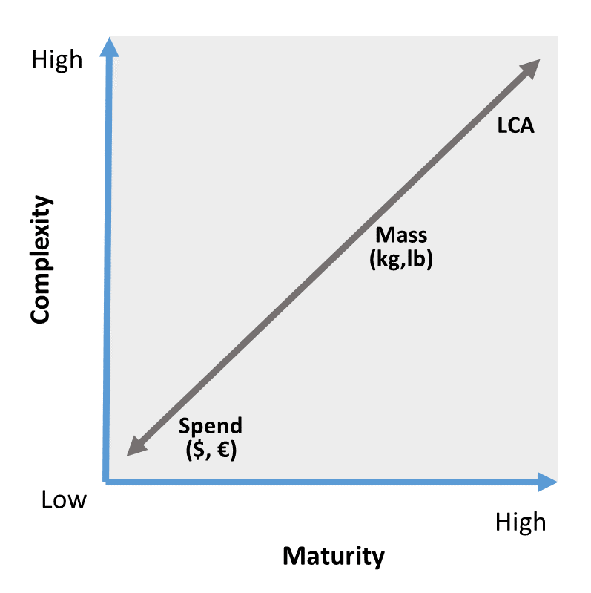
Figure 1: Schematic of the available approaches with respect to maturity and complexity

Main features of the methodology
The goal of this methodology is to offer aerospace companies a way of quantifying GHG emissions while accounting for the varying operational capabilities among companies. A three-approach methodology was developed where users of the methodology are invited to choose among three ways to calculate their emissions. The selection of the appropriate approach depends on the familiarity of the user with Scope 3 accounting, the level of accuracy required, the data available to the user and the human resources available for data collection.
The three approaches are “Spend-based”, “Hybrid” and “Mass-based”.
- The Spend-based approach enables users to estimate GHG emissions based solely on the company’s expenditure data (i.e., purchase orders, general ledger, etc.).
- The Hybrid approach allows users to use a mix of both expenditure data and physical data for their analysis.
- The Mass-based approach allows users to base their calculations mostly on physical characteristics such as the mass breakdown of products to achieve a more accurate GHG assessment.
Table 1 provides an overview of key features to facilitate the comparison between each approach’s strengths and weaknesses.
Table 1: overall presentation of the three approaches
Approach | Spend-based | Hybrid | Mass-based
Accuracy | Low | Medium | Medium - High
Granularity | Low | Low-medium | Medium - High
Data input complexity | Low | Medium | High
Estimated level of effort | A few hours | A few days | A few weeks

Purchased Goods & Services categories for the purpose of GHG accounting
Purchased goods and services are classified into 16 categories relevant to the aerospace and defense industry value chain, organized into 4 general groups. The categories are the same across all 3 approaches of this methodology, but the granularity and type of Emissions Factor (EF) in each category vary between approaches.
Table 2 shows the organization of groups / categories and subcategories as well as the type of EF that are available for each subcategory.
Table 2: Categorization of PG&S
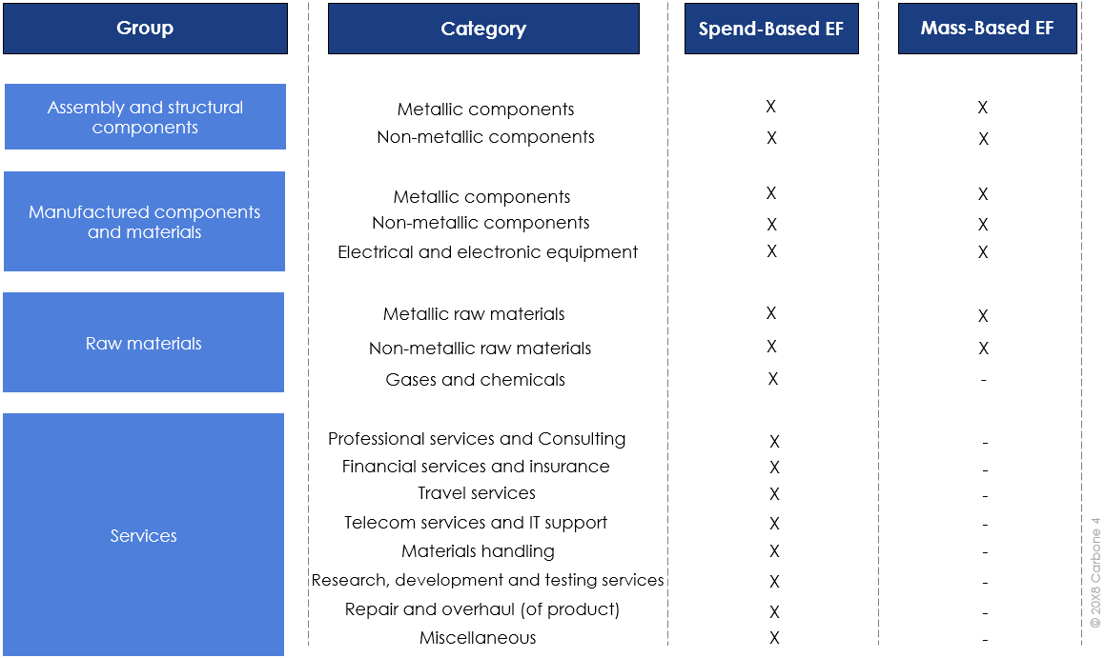

Capital Goods categories for the purpose of GHG accounting

Table 3 shows the organization of proposed groups / categories and subcategories for CG.

Table 3: Categorization of CG
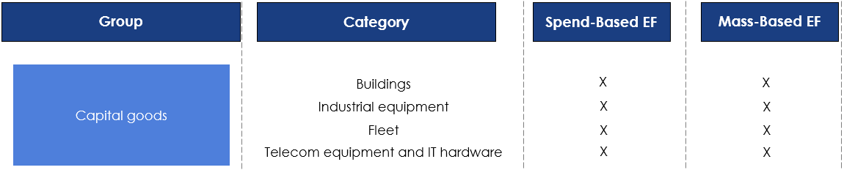

Step-by-step guide
This section provides the instruction to guide the user through the use of the tool. In each section, references are made to the corresponding sheet in the Excel tool.

Getting familiar with the tool – “Read me” sheet
The user should consult the “Read me” sheet before starting an assessment as it contains all the necessary basic information to start using the tool. In particular, it indicates:
- the significance of the color code;
- input cells and restricted (calculated) cells

Identifying the relevant assessment approach – “Decision tree” sheet -
Choosing the appropriate approach for each company depends on several factors: the familiarity of the user with Scope 3 accounting, the level of accuracy required, the data available to the user and the availability of the resources to collect data.
The user should determine the assessment approach best suited for their needs, available resources, and available data based on the decision tree shown in Figure 2.
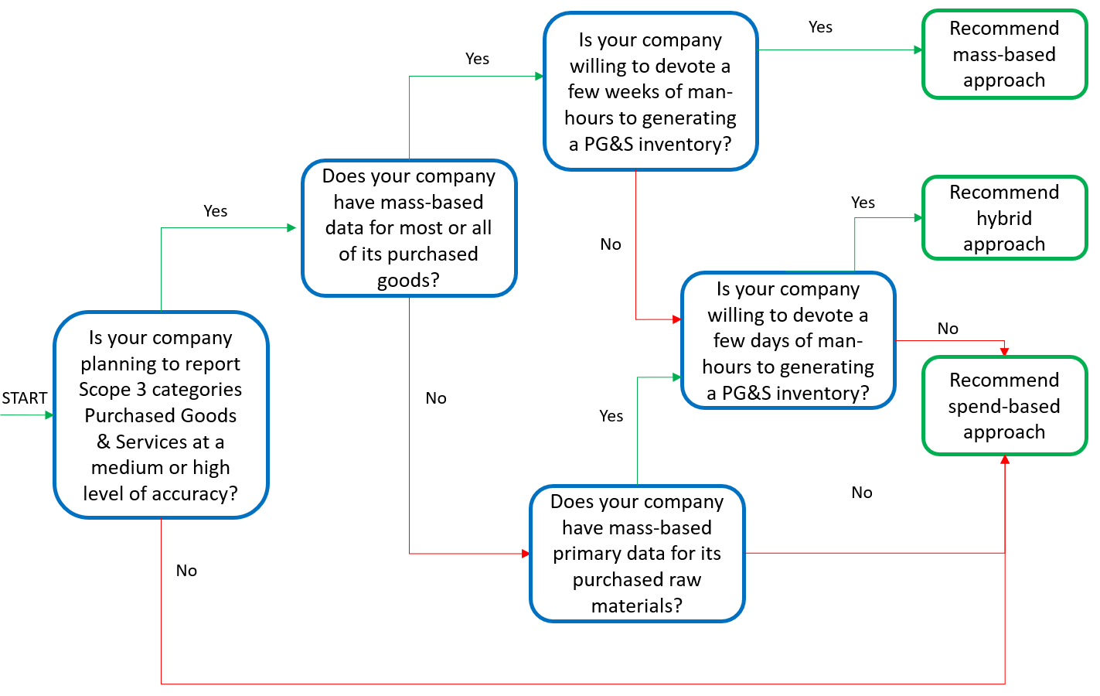
Figure 2: Decision tree for the selection of the appropriate assessment approach
In the Decision Tree sheet, answer the questions by “Yes” or “No” to identify the most relevant approach to the reporting company’s situation. Specify the year for which the analysis will be conducted.
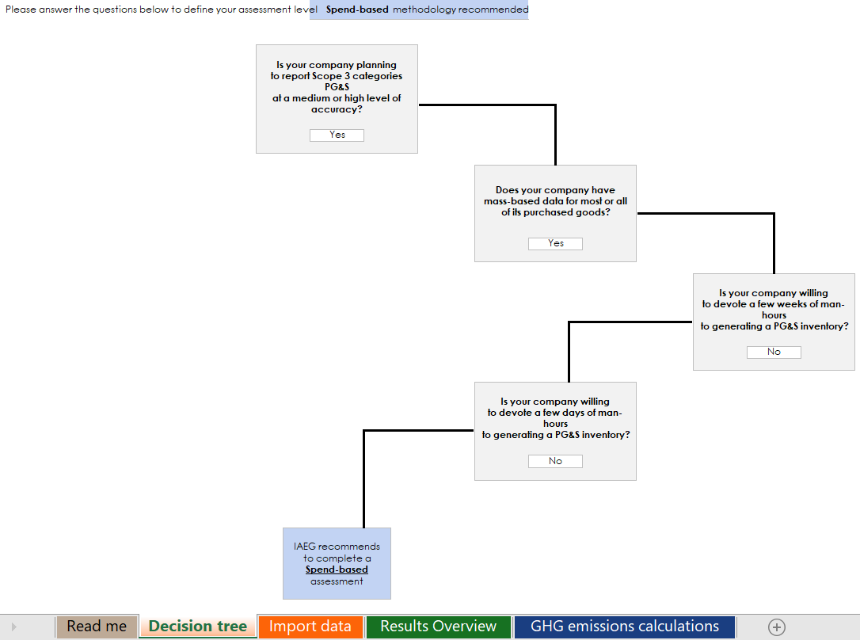
Figure 3: Decision tree as displayed in the tool

Data collection

Identifying data source
To complete an assessment of Scope 3 emissions for PG&S and CG, the user needs to first dedicate time for data collection. As presented in the previous paragraphs, the information needed for the calculations is either derived from spend-based or mass-based data.
Spend-based data are likely to be located in internal purchase databases within the company. The target dataset should account for 100% of Enterprise spend (or as close as possible), representing all in-scope company entities as per the GHG Protocol’s definition of operational boundary.
Mass-based data are generally owned by dedicated teams within the company, such design, procurement, or production departments, as they often record information on raw materials or aerostructures.

Ensuring materiality in data collection
Aerospace reporters should aim to account for all PG&S and CGs goods from their operations. However, as explained in ISO/TR 14069, organizations often have incomplete records of purchased goods. Therefore, ensuring the completeness of the data collection is often a challenge, especially when dealing with PG&S and CG.
To ensure an adequate level of accuracy, the reporting company should identify subcategories that are likely to be the most significant or material from a GHG emissions standpoint. Significant GHG emissions are defined in ISO14064:2018 whereas materiality is defined in the GHG Protocol Corporate Value Chain Accounting and Reporting Standard. For a company with limited or no previous experience in PG&S GHG emissions estimation, performing an initial assessment of the PG&S through the spend-based approach could help identify which emissions subcategories are significant or material. Should the reporting company decide to exclude sources of emissions, it must justify its decisions and demonstrate that the total economic value or total mass is inferior to a pre-defined exclusion threshold.
The reporting company should clearly describe which PG&S subcategories are taken into account in the analysis. Similarly, it should state and justify the ones that are excluded and the extent to which it affects the total GHG emissions.
To ensure data quality, please refer to the Chapter on "Managing Inventory Quality" (Chapter 7) of the GHG Protocol Corporate Standard which gives guidance on how to plan and implement a GHG Data Quality Management System.

Data tracking
The reporting company should keep records of the raw data used for the analysis to support any audit or verification process, and to promote comparability of results across successive years. Note that the accuracy of the overall analysis is highly dependent on the accuracy and completeness of the collected input data.
The reporting company should especially keep a copy of the methodology and the tool used for assessing emissions from PG&S and CG.
The data that may be reviewed by an auditor include:
- Emission factors value, units, sources and years;
- Emission factors computation formula (if they are computed);
- Spend or mass-based inputs.

Filling with the inputs – “Import data” sheet

Mapping categories
As a first step, it is recommended that the user become familiar with Table 2 and Table 3. For more detailed information on available emission factors (EFs), the user can also refer to the GHG emissions calculation sheet of the tool.
Users must then determine a mapping from each internal purchasing category to an appropriate corresponding subcategory of the IAEG Scope 3 methodology. This mapping activity is initially done the first time the methodology is used and is a prerequisite for the first assessment of PG&S and CG emissions. This process should be repeated in subsequent assessments on a case-by-case basis, in particular when the purchasing databases evolve or when new subcategories are added to the methodology.
The following subsection provides detailed instructions on the matching step.
In the Import Data tab, fill in the required information for each group, both for PG&S and CG.
- Fill in columns ‘Expenditure ID’ and ‘Expenditure label’ with the relevant information from the reporting company PG&S database. Expenditure ID may be a unique identifier per line item such as (1), or PGS1, etc. Expenditure label may be the purchasing category label assigned in the reporting company’s expenditure data or supply chain report.
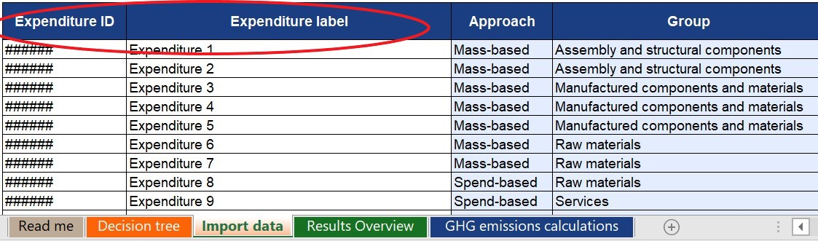
Figure 4: Screenshot of the tool focusing on Expenditure ID and Expenditure label
- In the ‘Group’ column, select the category that maps to the expenditure from the drop-down menu
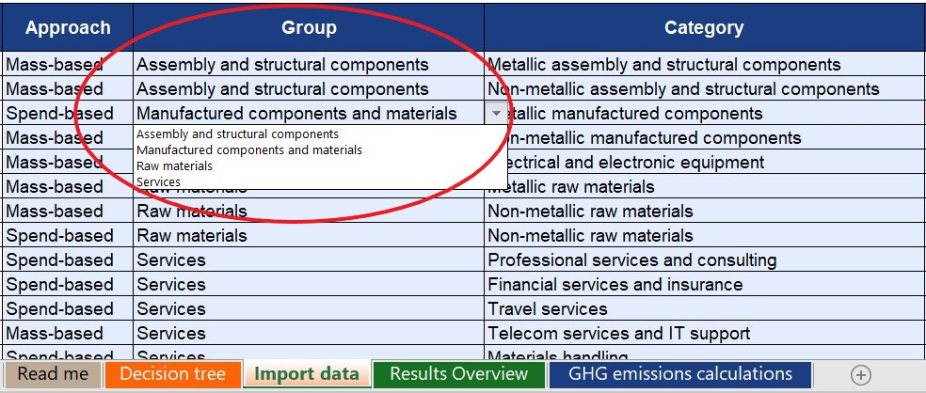
Figure 5: Screenshot of the tool focusing on “Group” column
Note: if any of the drop-down menu does not appear at some point in the process, restart from the “Group” or Category” cell.
- In the ‘Category’ column, select the category that best fits the expenditure in from the drop-down menu
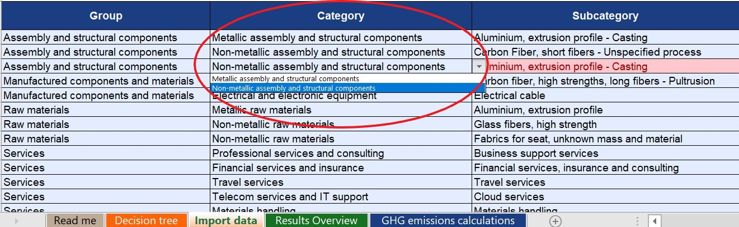
Figure 6: Screenshot of the tool focusing on “Category” column
- In the ‘subcategory’ column, select the subcategory that best fits the expenditure in from the drop-down menu
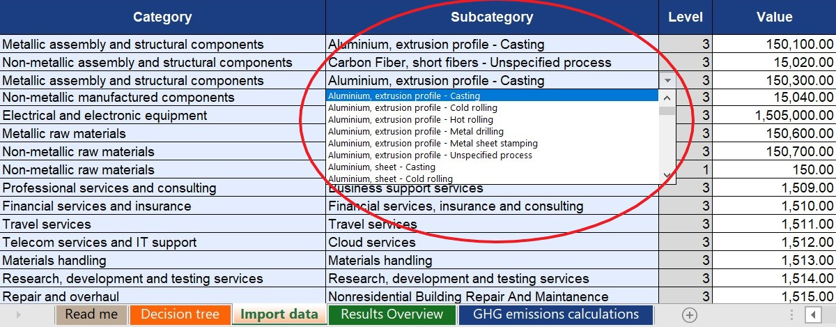
Figure 7: Screenshot of the tool focusing on “subcategory” column
- In the ‘Value’ column, enter the value in the unit specified in the “unit” column. The unit column is pre-populated based on the selection of Approach in column G.
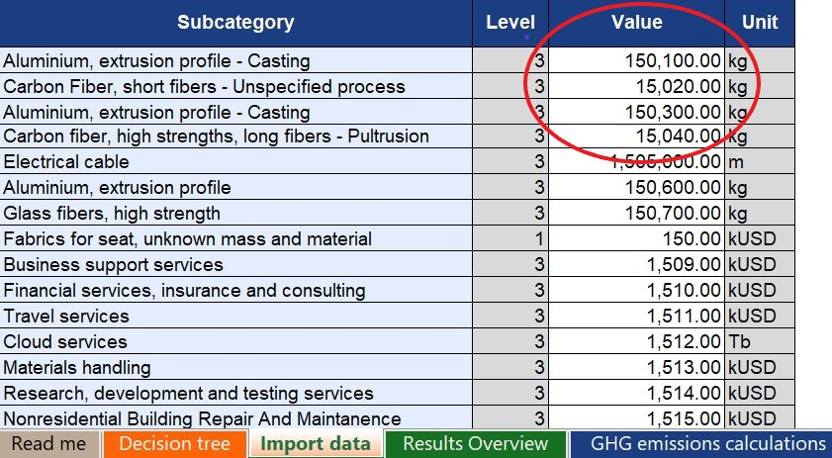
Figure 8: Screenshot of the tool focusing on “Value” column
- For each item, fill in the required information in the tables on the right. The information in these tables will facilitate the tracking and mapping of sources, with the aim that it is easily reproducible thereafter. This concerns data sources, contacts, assumptions, etc.
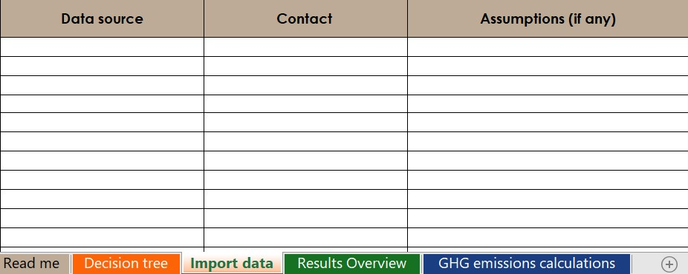
Figure 9: Screenshot of the tool focusing on data tracking information

Category and subcategory examples
The following section represents examples provided by WG3 members to facilitate mapping of common purchasing categories to Groups and Categories provided in this tool. These examples should be considered as representative guidance only, and each reporting company should proceed with mapping in accordance with its own internal policies and procedures.

Standardized goods
The Aerospace & Defense components manufacturing industry has extensive standards that are an integral part of the purchasing process. These apply to a wide range of goods and are based on industry or US Government Specifications. These include fasteners (screws, nuts, bolts…), hoses, clamps, seals, brackets, etc.
The standardization of these goods may simplify reporting efforts by providing information relating to its material composition. Over the years, users may also use the standardized identification of these parts to keep track of how they are categorized in the tool.
Fasteners, as an example, are metal based goods and should be classified accordingly in the IAEG tool
Category: Assembly and structural components
Sub-category: Metal based assembly and structural component for aircraft/space vehicle and missiles

Complex goods
When dealing with complex goods, users should identify the main material making up the good and select this category in the IAEG tool. The assistance of procurement, supply chain, or engineering colleagues may be required to do this approximation as accurately as possible.
Landing Gear Systems are an example of a complex component likely to be encountered by users of the tool. These systems include elements like hydraulics, structural sections, energy absorption systems, brakes, wheels, and tires. While several materials are used, high-strength steel and titanium alloys are in greatest presence. Hence, the selection in the tool would go as follows:
Category: Manufactured components and materials
Sub-category: Metal based manufactured components for aircraft (other than engines)

Industrial equipment
Certain capital goods such as machine tooling or assembly and transportation jigs, are internal purchasing categories that can account for a significant part of a company’s annual spending. The IAEG tool has therefore identified subcategories for these materials:
Category: Industrial equipment
Sub-Category: Machines and industrial equipment

Back-end calculations – “GHG emissions calculation” sheet
The “GHG emissions calculation” tab performs the GHG emissions calculations based on the data entered in the “Import data” tab. The values entered in the “Import data” tab are multiplied by the appropriate EF to derive a subcategory’s emissions in metric tons of CO2. The applicable subcategories are shown in blue and subcategories that are not filled in on the “Import Data” tab remain grayed out.
The values calculated in “GHG emissions calculation” then are used to build the graphs in the “Results Overview” tab. Please note that no action is required from the user for this tab to work properly.

Reviewing the results – “Results overview” sheet
Once all data has been entered, go to the Results Overview tab to view the results.

Associated emissions and share of total emissions
In the first section of the results tab, a table displays the results of the data according to the information entered in the “import data” tab. The categories of PG&S and CG are presented by their groups to allow the user to better understand the most important categories of emission within each group. An example of the table is provided in Figure 10.
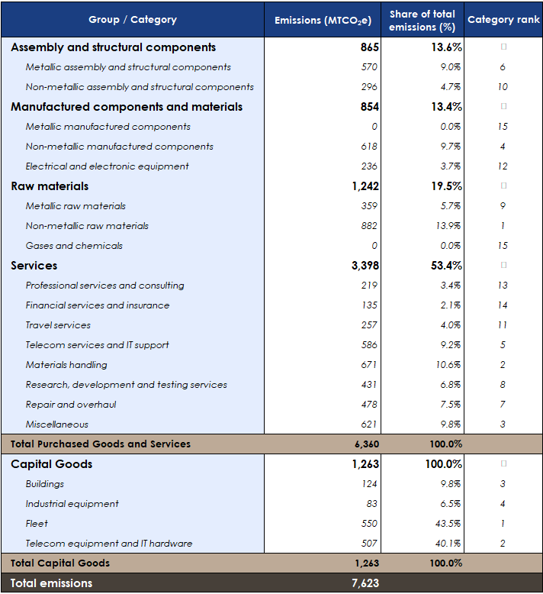
Figure 10: Associated emissions and share of total emissions table
This first section also contains three charts to help the user visualize the source of their emissions (see Figure 11). The first pie chart displays the data for both PG&S and CG. The second and third pie charts display the same data separately. Beneath each pie chart is a stacked bar which provides information on the percentage of total emissions derived from spend-based and mass-based EF.
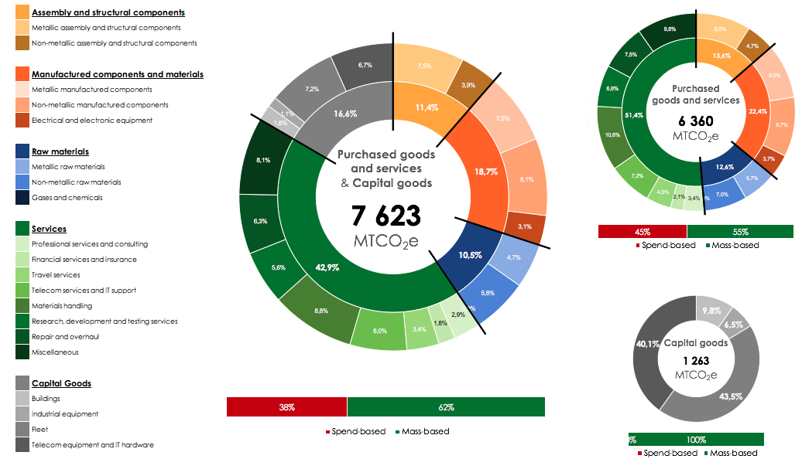
Figure 11: Associated emissions and share of total emissions graphs

Distribution of GHG emissions by degree of decreasing significance
In the second section of the results tab, a table (see Figure 12) displays the results of the data by decreasing share of the total emissions to allow the user to better understand the most impactful categories of emission in their overall inventories.
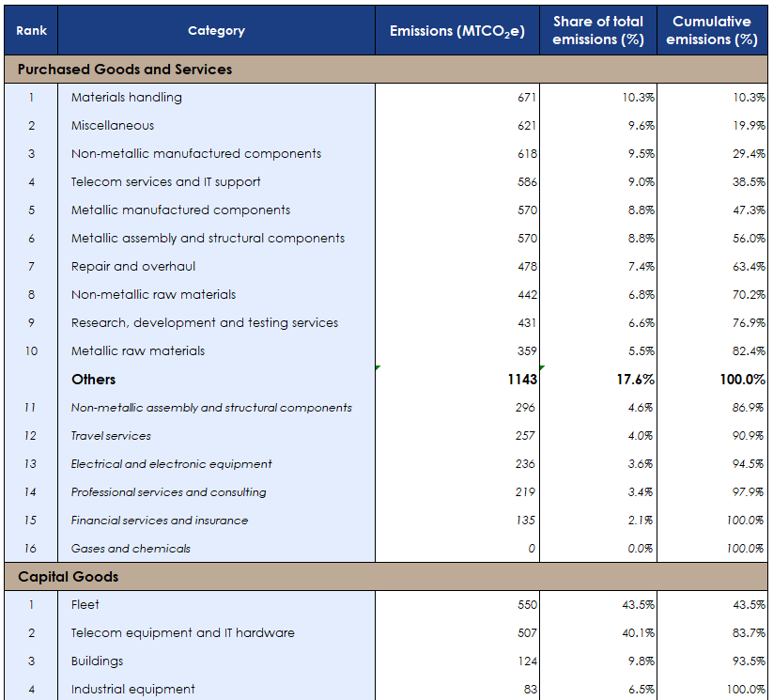
Figure 12: GHG emissions distribution table
The second section also contains two charts to help the user visualize the impact of their total emissions from each category. The graphs display the data for PG&S and CG separately as shown in Figure 13. The bars indicate total emissions per category mapped on the primary y-axis, while the line indicates cumulative emissions represented by the categories on the chart mapped on the secondary y-axis.

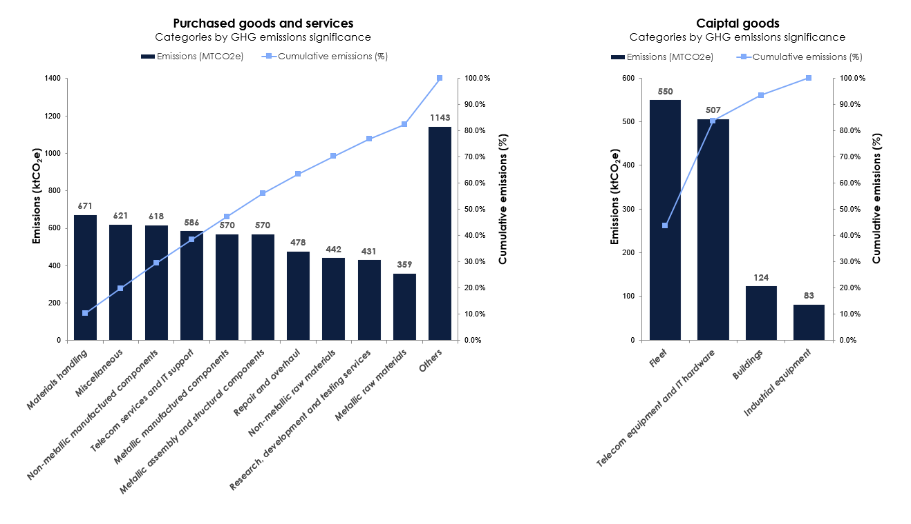
Figure 13: GHG emissions distribution graphs

Conclusion
This guide describes how to perform an assessment of GHG emissions from PG&S and CG for aerospace and defense companies. By following the instructions, the user will be carried through each step of the process, including the use of the Excel tool developed in support of the methodology.

https://ghgprotocol.org/standards/scope-3-standard
https://ghgprotocol.org/standards/scope-3-standard
https://ghgprotocol.org/corporate-standard

